**______________________________________________________**

**UCT 602**

**INFORMATION SECURITY**

**LAB ASSIGNMENTS**

**______________________________________________________**



**SUBMITTED TO: DR GURPAL SINGH**

**DIVIJA 102018056 CSBS3**

**MULTIPLICATIVE**

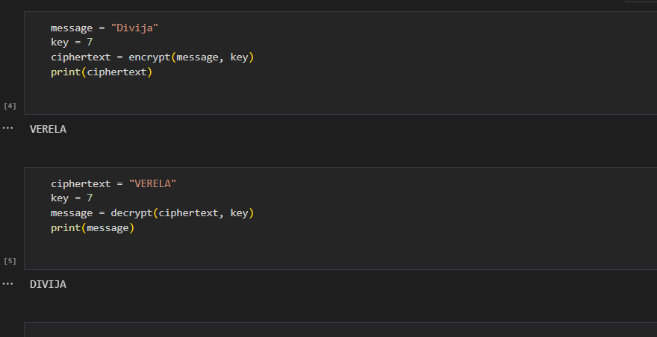

**AUTOKEY**

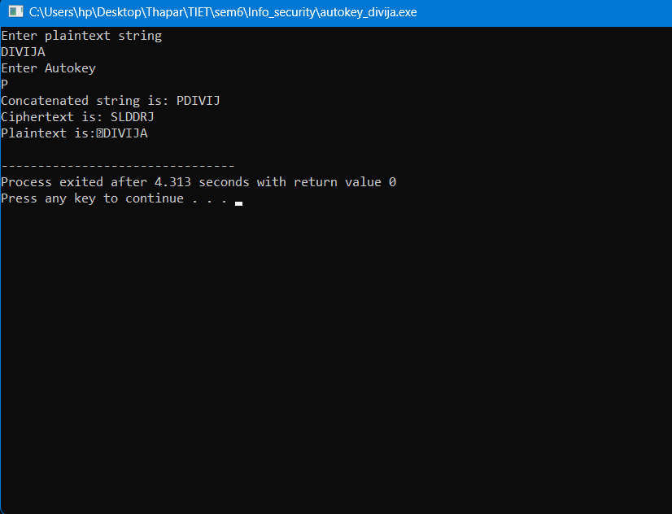

**VIGENERE**

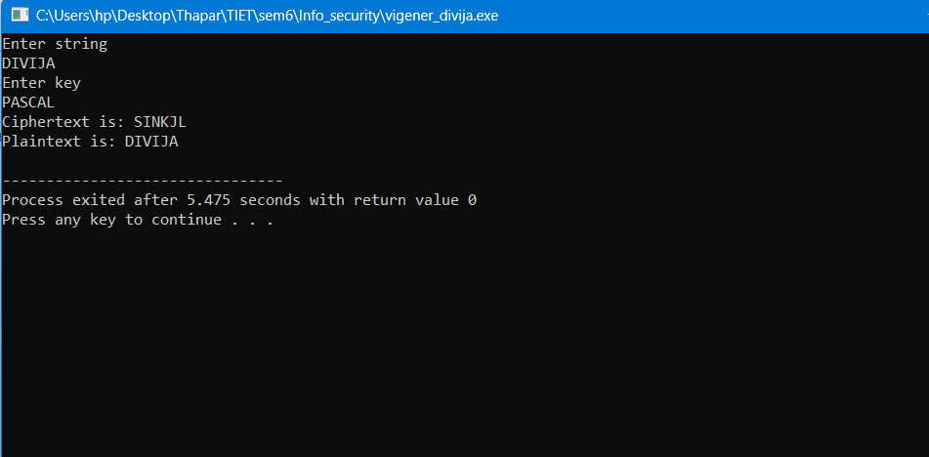

**AFFINE**

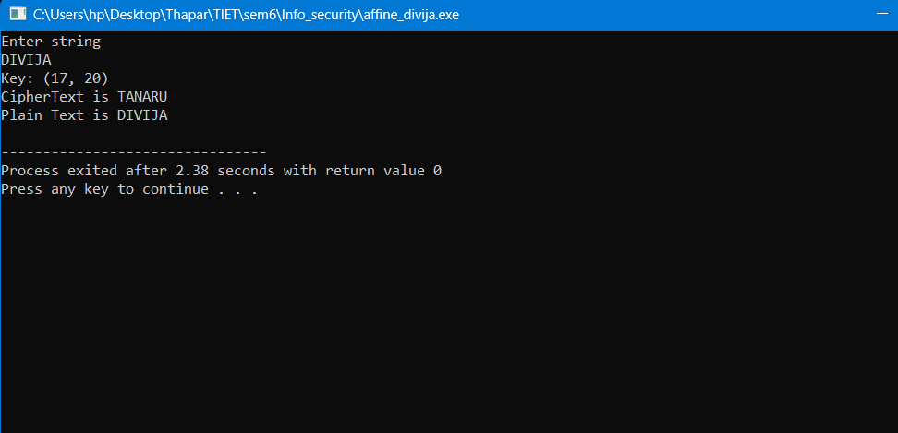

**PLAYFAIR**

